Electromagnetic Induction

Magnetic Field Lines
Magnets are surrounded by magnetic fields. A magnetic field can be thought of as consisting of lines of force.
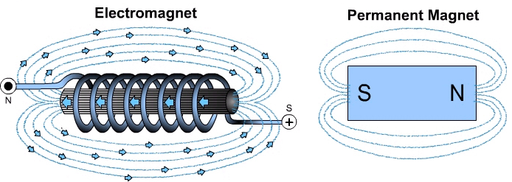
Note the circular pattern of the field lines.

Current produces a magnetic field. A changing magnetic field causes a potential difference (voltage) in a conductor. This potential difference produces current.

Electromagnetism
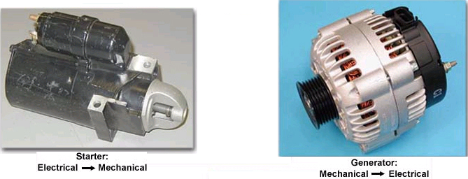
- Used to operate and control various automotive components
- Converts electrical energy to mechanical energy
- Converts mechanical energy into electrical energy

Hall Effect
In 1879 E.H. Hall discovered that when he placed a metal strip carrying a current in a magnetic field, a voltage difference was produced across the strip. The current created in the conductor is alternating because it moves back and forth.
Uses of the Hall effect on automotive systems include vehicle speed sensors, wheel speed sensors, and crankshaft position sensors.

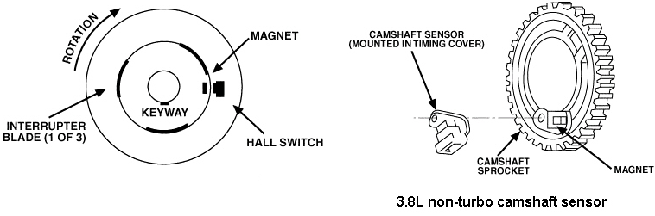
The Hall effect sensor is an accurate way for a computer to “see” the exact position or measure the speed of a rotating device. Most designs utilize a shutter which passes through an opening in the sensor. The opening has a magnetic field passing across from a permanent magnent to the electronic switch. When the shutter passes through the magnetic field, it is interrupted and a change of voltage is sensed by the computer.

Electromagnetic Induction
As a magnetic field moves across a conductor, electrons are forced across the conductor by the changing magnetic field. When the electrons move to one end of the conductor that end is now negatively charged and the other end is positive. As a result of this difference in charge the conductor possesses a potential difference
(voltage).
- Moving a magnet in or out of a wire coil produces a current
- Amount of voltage induced depends on how quickly the magnetic field lines pass the wire.
  - Slow motion = low voltage
  - Quick motion = high voltage
